**3.1.6.1 WIP Contract Details**

# Purpose:

The purpose of this screen is to let the Agency, Broker or Principal user create the WIP progress history details by entering the contract data for the system to review the WIP details and help in the underwriting process of the bond request.

# Page Activation:

Pro Tools URL: <http://www.xenexhost.com:10080/Protools/index.jsp?agencyId=1&agencyBranchId=1>

**Agency User**

**Existing Account**: Login > Search or Inbox > Click on Company Name > WIP

**Principal User**

**Existing Account**: Login > Bond Manager > WIP

**Broker User**

**Existing Account**: Login > Bond Manager > WIP

# Page Security:

This screen is accessible to the Agent, Principal and Broker users

# Screen Images

Work in Progress (WIP) screen:

Principals View of WIP: View WIP will display a list of the quarters (or the schedule set up by the underwriter – if schedule setup is monthly, the drop will display a list of all the months and if quarter, then the list will display the 4 quarters) and if selected any quarter, will display a list of all the contracts that were either added or modified during that quarter based on the saved timestamp.

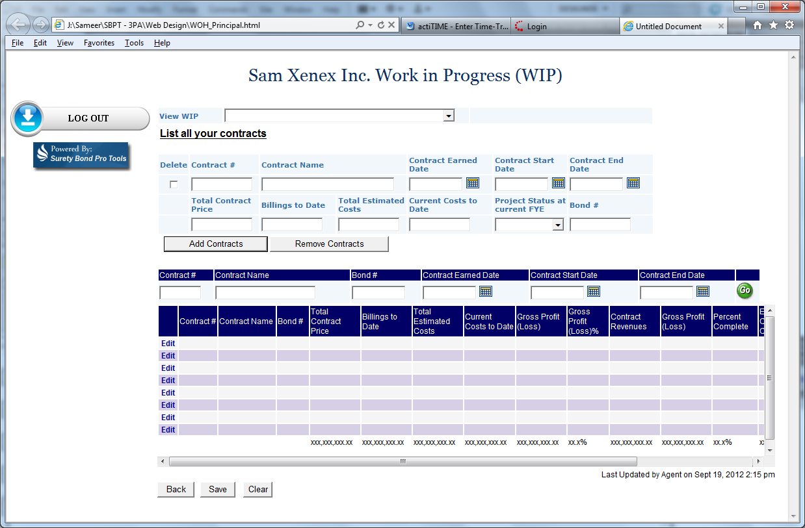

Agents view of WIP:

Gross Profit Summary (button) will open the summary calculations screen (as in summary tab of the WIP excel document sent by Mike)

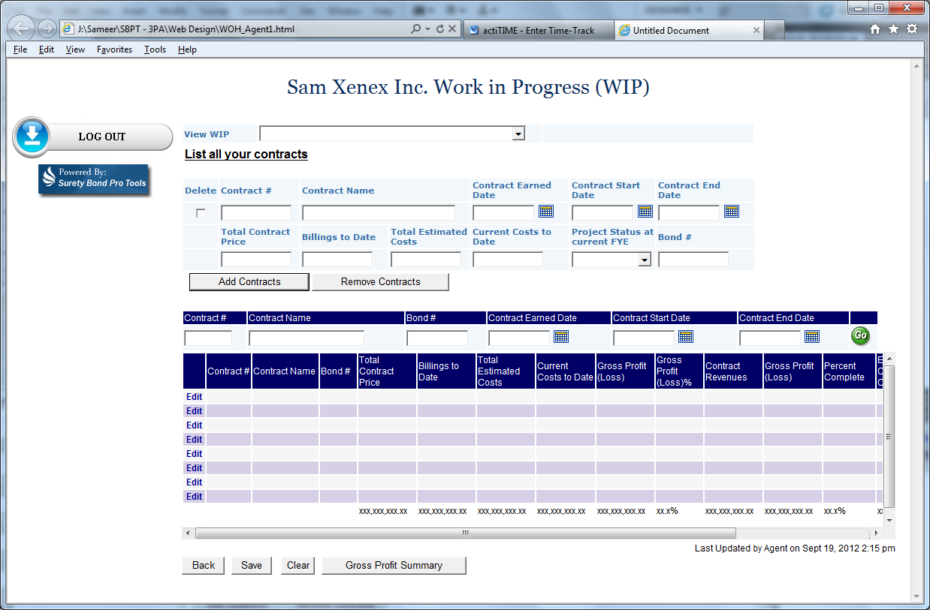

Carrier Underwriter’s view of WIP:

Gross Profit Summary (button) will open the summary calculations screen (as in summary tab of the WIP excel document sent by Mike)

WIP update schedule will display a list of the update setup by the carrier underwriter. List will include values like Monthly, Quarterly, Bi Annually and Annually.

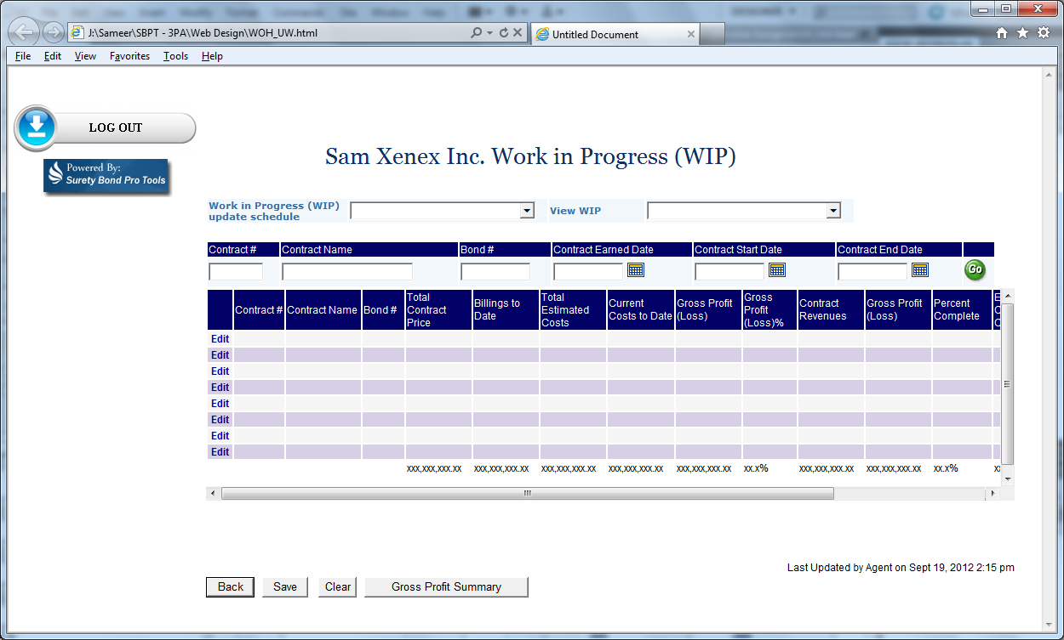

# Page Tabs and Menus

Please refer to the functional decomposition to follow the Tabs and Menus

# General Information:

Please refer the .css (style sheet) document for page and font styling

Please refer to the Pro Tools Contract Bond flow document to understand the business logic and the workflow for agency Sign-Up and Bond request applications.

# 7 Page Controls:

Please see following tables for details on page controls.

| Page Controls  Legend: Mandatory/Optional Column: D = Display Only, M = Mandatory Entry, O = Optional Entry, N = Not Visible | | | | | | |
| --- | --- | --- | --- | --- | --- | --- |
| Label | Control Type | Tab Order | Enabled | Mandatory / Optional | Database Column Name | Validation Criteria / Notes |
| Powered By: Surety Bond Pro Tools | **Image** |  | Y | D |  | **Type:** Image  Left aligned (left navigation image panel section) |
| Logout | **Image** |  | Y | D |  | **Type:** Image  Left aligned (left navigation image panel section)  Refer to Section 8 – Buttons and Action Links |
| <Account Name> Work in Progress (WIP) | **Label** |  | Y | D |  | Display the Account Name followed by the label  **CSS:** style Header 3 (h3) |
| Work in Progress (WIP) Update Schedule | **Label** |  | Y | D |  | **CSS:** style= PropertyLabelCell |
| Work in Progress (WIP) Update Schedule | **Drop Down List** | 1 | Y | O |  | **Data type:** look-up table values  **Field length:** NA  **Format:** NA  **Default value:** Blank  **Validation:** N/A  **Behaviour:** User selection field. Display this field ONLY if the user = Carrier Underwriter, else hide this label and field. (If user = Agent user, Principal or Broker, hide this field)  **Privilege:** Refer to Section 3 - Page Security |
| View WIP | **Label** |  | Y | D |  | **CSS:** style= PropertyLabelCell |
| View WIP | **Drop Down List** | 2 | Y | O |  | **Data type:** look-up table values  **Field length:** NA  **Format:** NA  **Default value:** Blank  **Validation:** N/A  **Behaviour:** User selection field  **Privilege:** Refer to Section 3 - Page Security |
| List all your contacts | **Label** |  | Y | D |  | **CSS:** style Header 3 (h3)  Hide this Label if the user = Carrier Underwriter |
| Delete | **Check Box** | 3 | Y | O |  | **Data type:** Boolean  **Field length:** 1  **Format:** Left justified  **Default value:** Unchecked  **Validation:** Hide this check box if the user = Carrier Underwriter  **Behaviour:** User selection field  **Privilege:** Refer to Section 3 - Page Security |
| Contract # | **Label** |  | Y | D |  | **CSS:** style= PropertyLabelCell |
| Contract # | **Text Field** | 4 | Y | O |  | **Data type:** Alpha-Numeric  **Field length:** 50  **Format:** Left Justified  **Default value:** Blank  **Validation:** Hide this field if the user = Carrier Underwriter  **Behaviour:** User entry field  **Privilege:** Refer to Section 3 - Page Security |
| Contract Name | **Label** |  | Y | D |  | **CSS:** style= PropertyLabelCell |
| Contract Name | **Text Field** | 5 | Y | O |  | **Data type:** Alpha-Numeric  **Field length:** 50  **Format:** Left Justified  **Default value:** Blank  **Validation:** Hide this field if the user = Carrier Underwriter  **Behaviour:** User entry field  **Privilege:** Refer to Section 3 - Page Security |
| Contract Earned Date | **Label** |  | Y | D |  | **CSS:** style= PropertyLabelCell |
| Contract Earned Date | **Calendar Tool** |  | Y | O |  | **Data type:** Date  **Field length:**  N/A  **Format:** MM/DD/YYYY  **Default value:** Blank  **Validation:** Hide this field if the user = Carrier Underwriter  **Behaviour:**   * User selection field using the calendar tool * On selection of date from calendar tool, populate the field with the date selected * Can be back-dated   **Privilege:** Refer to Section 3 - Page Security |
| Contract Start Date | **Label** |  | Y | D |  | **CSS:** style= PropertyLabelCell |
| Contract Start Date | **Calendar Tool** |  | Y | O |  | **Data type:** Date  **Field length:**  N/A  **Format:** MM/DD/YYYY  **Default value:** Blank  **Validation:** Hide this field if the user = Carrier Underwriter  **Behaviour:**   * User selection field using the calendar tool * On selection of date from calendar tool, populate the field with the date selected * Can be back-dated * Cannot be earlier than Contract Earned Date   **Privilege:** Refer to Section 3 - Page Security |
| Contract End Date | **Label** |  | Y | D |  | **CSS:** style= PropertyLabelCell |
| Contract End Date | **Calendar Tool** |  | Y | O |  | **Data type:** Date  **Field length:**  N/A  **Format:** MM/DD/YYYY  **Default value:** Blank  **Validation:** Hide this field if the user = Carrier Underwriter  **Behaviour:**   * User selection field using the calendar tool * On selection of date from calendar tool, populate the field with the date selected * Can be back-dated * Cannot be earlier than Contract Start Date   **Privilege:** Refer to Section 3 - Page Security |
| Total Contract Price | **Label** |  | Y | D |  | **CSS:** style= PropertyLabelCell |
| Total Contract Price | **Text Field** | 6 | Y | O |  | **Data type:** Alpha-Numeric  **Field length:** 50  **Format:** Left Justified  **Default value:** Blank  **Validation:** Hide this field if the user = Carrier Underwriter  **Behaviour:** User entry field  **Privilege:** Refer to Section 3 - Page Security |
| Billings to Date | **Label** |  | Y | D |  | **CSS:** style= PropertyLabelCell |
| Billings to Date | **Text Field** | 7 | Y | O |  | **Data type:** Alpha-Numeric  **Field length:** 50  **Format:** Left Justified  **Default value:** Blank  **Validation:** Hide this field if the user = Carrier Underwriter  **Behaviour:** User entry field  **Privilege:** Refer to Section 3 - Page Security |
| Total Estimated Costs | **Label** |  | Y | D |  | **CSS:** style= PropertyLabelCell |
| Total Estimated Costs | **Text Field** | 8 | Y | O |  | **Data type:** Alpha-Numeric  **Field length:** 50  **Format:** Left Justified  **Default value:** Blank  **Validation:** Hide this field if the user = Carrier Underwriter  **Behaviour:** User entry field  **Privilege:** Refer to Section 3 - Page Security |
| Current Cost to Date | **Label** |  | Y | D |  | **CSS:** style= PropertyLabelCell |
| Current Cost to Date | **Text Field** | 9 | Y | O |  | **Data type:** Alpha-Numeric  **Field length:** 50  **Format:** Left Justified  **Default value:** Blank  **Validation:** Hide this field if the user = Carrier Underwriter  **Behaviour:** User entry field  **Privilege:** Refer to Section 3 - Page Security |
| Project Status at Current FYE | **Label** |  | Y | D |  | **CSS:** style= PropertyLabelCell |
| Project Status at Current FYE | **Drop Down List** | 10 | Y | O |  | **Data type:** look-up table values  **Field length:** NA  **Format:** NA  **Default value:** Blank  **Validation:** Hide this field if the user = Carrier Underwriter  **Behaviour:** User selection field  **Privilege:** Refer to Section 3 - Page Security |
| Bond # | **Label** |  | Y | D |  | **CSS:** style= PropertyLabelCell |
| Bond # | **Text Field** | 11 | Y | O |  | **Data type:** Alpha-Numeric  **Field length:** 50  **Format:** Left Justified  **Default value:** Blank  **Validation:** Hide this field if the user = Carrier Underwriter  **Behaviour:** User entry field  **Privilege:** Refer to Section 3 - Page Security |
| Add Contract | **Button** | 12 | Y | D |  | **Type:** Button  Refer to Section 8 – Buttons and Action Links |
| Remove Contract | **Button** | 13 | Y | D |  | **Type:** Button  Refer to Section 8 – Buttons and Action Links |
| Data display and search filters | | | | | |  |
| Contract # | **Label** |  | Y | D |  | **CSS:** style= TblHeader |
| Contract # | **Text Field** |  | Y | O |  | **Data type:** Alpha-Numeric  **Field length:** 20  **Format:** Left Justified  **Default value:** Blank  **Validation:** N/A  **Behaviour:** User entry field for search parameter  **Privilege:** Refer to Section 3 - Page Security |
| Contract Name | **Label** |  | Y | D |  | **CSS:** style= TblHeader |
| Contract Name | **Text Field** |  | Y | O |  | **Data type:** Alpha-Numeric  **Field length:** 50  **Format:** Left Justified  **Default value:** Blank  **Validation:** N/A  **Behaviour:** User entry field for search parameter  **Privilege:** Refer to Section 3 - Page Security |
| Bond # | **Label** |  | Y | D |  | **CSS:** style= TblHeader |
| Bond # | **Text Field** |  | Y | O |  | **Data type:** Alpha-Numeric  **Field length:** 20  **Format:** Left Justified  **Default value:** Blank  **Validation:** N/A  **Behaviour:** User entry field for search parameter  **Privilege:** Refer to Section 3 - Page Security |
| Contract Earned Date | **Label** |  | Y | D |  | **CSS:** style= TblHeader |
| Contract Earned Date | **Calendar Tool** |  | Y | O |  | **Data type:** Date  **Field length:**  N/A  **Format:** MM/DD/YYYY  **Default value:** Blank  **Validation:** N/A  **Behaviour:**   * User selection field using the calendar tool * On selection of date from calendar tool, populate the field with the date selected   **Privilege:** Refer to Section 3 - Page Security |
| Contract Start Date | **Label** |  | Y | D |  | **CSS:** style= TblHeader |
| Contract Start Date | **Calendar Tool** |  | Y | O |  | **Data type:** Date  **Field length:**  N/A  **Format:** MM/DD/YYYY  **Default value:** Blank  **Validation:** N/A  **Behaviour:**   * User selection field using the calendar tool * On selection of date from calendar tool, populate the field with the date selected   **Privilege:** Refer to Section 3 - Page Security |
| Contract End Date | **Label** |  | Y | D |  | **CSS:** style= TblHeader |
| Contract End Date | **Calendar Tool** |  | Y | O |  | **Data type:** Date  **Field length:**  N/A  **Format:** MM/DD/YYYY  **Default value:** Blank  **Validation:** N/A  **Behaviour:**   * User selection field using the calendar tool * On selection of date from calendar tool, populate the field with the date selected   **Privilege:** Refer to Section 3 - Page Security |
| Go | **Image** |  | Y | O |  | **Type: Image** (Button)  Refer to Section 8 – Buttons and Action Links |
| Data Grid | | | | | |  |
| Edit | **Link** |  | Y | O |  | **Type: Link**  Refer to Section 8 – Buttons and Action Links |
| Contract # | **Data Grid** |  | Y | D |  | **Type: Data Grid**  Refer to Section 9 – Data Grid |
| Contract Name | **Data Grid** |  | Y | D |  | **Type: Data Grid**  Refer to Section 9 – Data Grid |
| Bond # | **Data Grid** |  | Y | D |  | **Type: Data Grid**  Refer to Section 9 – Data Grid |
| Total Contract Price | **Data Grid** |  | Y | D |  | **Type: Data Grid**  Refer to Section 9 – Data Grid |
| Billing to Date | **Data Grid** |  | Y | D |  | **Type: Data Grid**  Refer to Section 9 – Data Grid |
| Total Estimated Cost | **Data Grid** |  | Y | D |  | **Type: Data Grid**  Refer to Section 9 – Data Grid |
| Current Cost to Date | **Data Grid** |  | Y | D |  | **Type: Data Grid**  Refer to Section 9 – Data Grid |
| Gross Profit (Loss) | **Data Grid** |  | Y | D |  | **Type: Data Grid**  Refer to Section 9 – Data Grid |
| Gross Profit (Loss) % | **Data Grid** |  | Y | D |  | **Type: Data Grid**  Refer to Section 9 – Data Grid |
| Contract Revenues | **Data Grid** |  | Y | D |  | **Type: Data Grid**  Refer to Section 9 – Data Grid |
| Gross Profit (Loss) | **Data Grid** |  | Y | D |  | **Type: Data Grid**  Refer to Section 9 – Data Grid |
| Percent Complete | **Data Grid** |  | Y | D |  | **Type: Data Grid**  Refer to Section 9 – Data Grid |
| Estimated Cost to Complete | **Data Grid** |  | Y | D |  | **Type: Data Grid**  Refer to Section 9 – Data Grid |
| Under Billings | **Data Grid** |  | Y | D |  | **Type: Data Grid**  Refer to Section 9 – Data Grid |
| (Over) Billings | **Data Grid** |  | Y | D |  | **Type: Data Grid**  Refer to Section 9 – Data Grid |
| Last Updated by | **Text Field** |  | Y | D |  | **Data type:** Alpha-Numeric  **Field length:**  25  **Format:** Left justify  **Default value:** Display name of the user who saved/updated the screen last time. If new, default to blank.  **Validation:** N/A  **Behaviour:** System generated text field. Not editable. Name of the user who saved/updated the screen. On save, replace information with new values.  **css style:**  **Privilege:** Refer to Section 3 - Page Security |
| On | **Text Field** |  | Y | D |  | **Data type:** TIMESTAMP  **Field length:**  N/A  **Format:**  mmm dd, yyyy at hh:mm PM/AM  **Default value:** Display Date & Time stamp when the screen was saved/updated  **Validation:** N/A  **Behaviour:** System generated text field. Not editable. Date & Time stamp when the screen was saved/updated. On save, replace information with new values.  **css style:**  **Privilege:** Refer to Section 3 - Page Security |
| Back | **Button** |  | Y | D |  | **Type:** Button  Refer to Section 8 – Buttons and Action Links |
| Save | **Button** | 14 | Y | D |  | **Type:** Button  Refer to Section 8 – Buttons and Action Links |
| Clear | **Button** | 15 | Y | D |  | **Type:** Button  Refer to Section 8 – Buttons and Action Links |
| Gross Profit Summary | **Button** | 16 | Y | D |  | **Type:** Button  Refer to Section 8 – Buttons and Action Links |

# Buttons and Action Links

| **Name** | **Action to be taken** |
| --- | --- |
| Add Contract | **Type:** Button  **Function:** The **Add Contract** button will display new line with all the text fields along with the Delete checkbox:  **Position:** **Add Contract** buttonwill be positioned at the bottom left of the delete checkbox  **Appearance:** General HTML button  **Security/privileges**:Refer to Section 3 - Page Security  **Edits:** Hide this button if the user = Carrier Underwriter  **Go to:** N/A |
| Remove Contract | **Type:** Button  **Function:** The **Remove Contract** button will remove the selected line from the screen if the delete checkbox is selected or else will display a message in red stating “Please select the job you want to remove”  **Position:** The **Remove Contract** button will be positioned next to **Add Contract** button  **Appearance:** General HTML button  **Security/privileges**:Refer to Section 3 - Page Security  **Edits:** Hide this button if the user = Carrier Underwriter  **Go to:** N/A |
| Back | **Type:** Button  **Function:** The **Back** button will take the user back to the screen where the user clicked the link to come to this screen  **Position:** **Back** button will be positioned to the left of the Save and Continue button  **Appearance:** General HTML button  **Security/privileges**:Refer to Section 3 - Page Security  **Edits:** N/A  **Go to:** The system will take the user back to the screen where the user clicked the link to come to this screen (Account details screen (Bond Manager)) |
| Save | **Type:** Button  **Function:** : The **Save** button will do the following:   * Check for all fields and if data exists in any of the fields save the record to the database. * Clear all the text fields in List all your Contracts section in this screen blank to start a new record   **Position:** **Save & Add another Resume** button will be positioned at the bottom left of the form  **Appearance:** General HTML button  **Security/privileges**:Refer to Section 3 - Page Security  **Edits:** N/A  **Go to:** N/A |
| Clear | **Type:** Button  **Function:** The **Clear** button will Clear all data from all fields in the form (default to on form load options)  **Position:** **Clear** button will be positioned to the right of the Save and Continue button  **Appearance:** General HTML button  **Security/privileges**:Refer to Section 3 - Page Security  **Edits:** N/A  **Go to:** N/A |
| Gross Profit Summary | **Type:** Button  **Function:** The **Gross Profit Summary** button will open the 3.1.6.2 WIP Summary screen  **Position:** **Gross Profit Summary** button will be positioned to the right of the Save and Continue button  **Appearance:** General HTML button  **Security/privileges**:Refer to Section 3 - Page Security  **Edits:** Display this button ONLY if the user = Carrier Underwriter and/or Agent user, else hide this button. (If user = Principal or Broker, hide this button)  **Go to:** 3.1.6.2 WIP Summary screen |

**9 Data Grid**

The Data Grid consists of 15 columns. The labels are displayed on a header row (Navy Blue with White font).

**Contract # : css style:** class = TblHeader

Display the Contract #

**Contract Name :** **css style:** class = TblHeader

Display the Contract name

**Bond # :** **css style:** class = TblHeader

Display the Bond #

**Total Contract Price:** **css style:** class = TblHeader

Display the Total Contract Price

**Billings to Date : css style:** class = TblHeader

Display the Billings to Date

**Total Estimated Costs :** **css style:** class = TblHeader

Display the Total Estimated Costs

**Current Costs to Date :** **css style:** class = TblHeader

Display the Current Costs to Date

**Gross Profit (Loss) :** **css style:** class = TblHeader

Display the Gross Profit (Loss)

**Gross Profit (Loss) % :** **css style:** class = TblHeader

Display the Gross Profit (Loss) %

**Contract Revenues :** **css style:** class = TblHeader

Display the Contract Revenues

**Gross Profit (Loss)** **: css style:** class = TblHeader

Display the Gross Profit (Loss)

**Percent Complete :** **css style:** class = TblHeader

Display the Percent Complete

**Estimated Costs to Complete :** **css style:** class = TblHeader

Display the Estimated Costs to Complete

**Under Billings**  **: css style:** class = TblHeader

Display the Under Billings

**(Over) Billings**   **:** **css style:** class = TblHeader

Display the (Over) Billings

**Totals :** **css style:** class = TblHeader

Display the Sum of the totals for each column

Headings and data to line up left justified.

Scrollbar appears if the search list does not fit in one page.

Header row – (Navy Blue with White fonts) – remains at top of screen as you scroll down.

Requirement to perform a left/right scroll to view all columns.

All fields should be displayed to the column width.

Search to return 100 matches followed by Next/Previous buttons at the bottom right of the screen.

After clicking **Go**, the search parameters entered will remain in the search fields.

Search results to be sorted using the following sort order:

Contract #

Contract Name

Bond #

Search results data **css style:** class = N/A

-- (Each column of the grid will have its own sort order. On click of the header label first time the search result will sort in ascending order and if click again it will sort in descending order) --